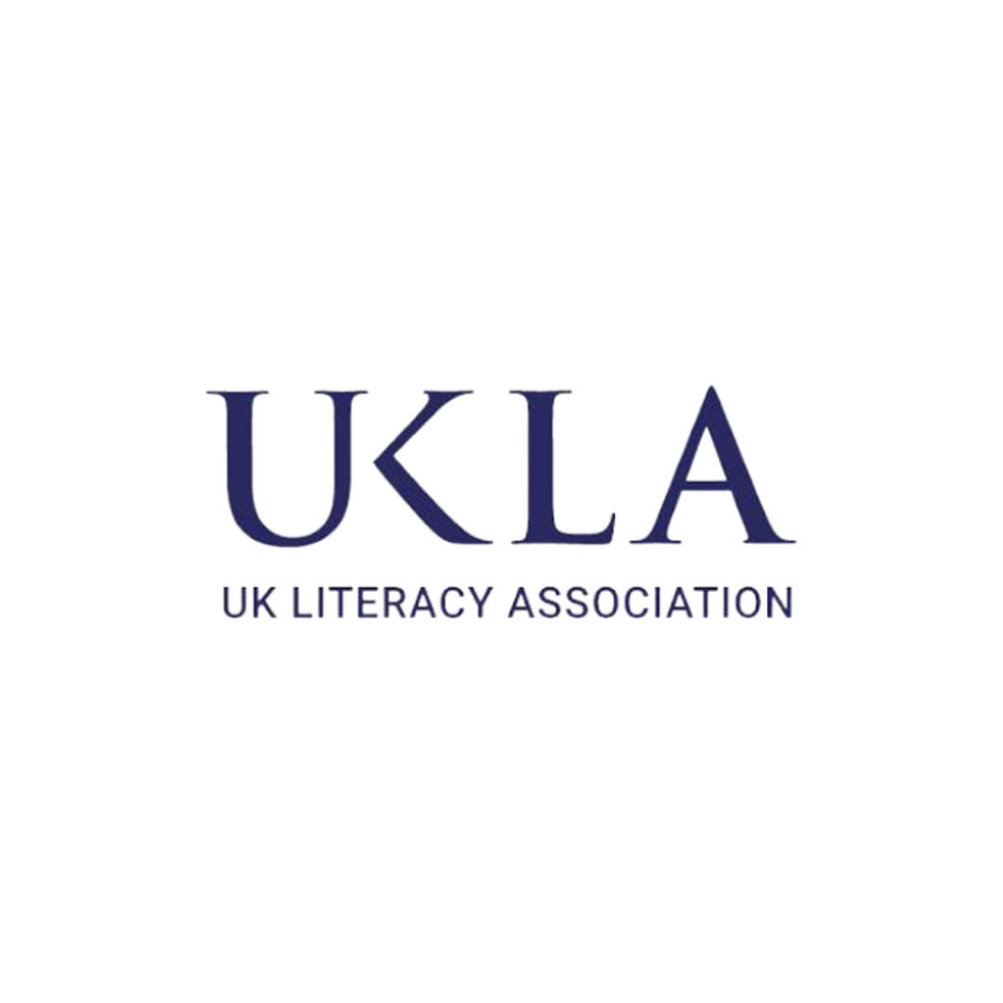
Book List for the ‘New’ Minorities
In the current post-COVID climate, and as highlighted by the Joseph Rowntree Foundation (2024), we are witnessing some of the highest levels of disadvantage among children. This situation has given rise to many new 'minorities' within our communities. The Centre for Literacy in Primary Education's (CLPE) Reflecting Realities research underscores the importance of seeking out quality books that value, explore, and reflect these diverse aspects of children's lives. In alignment with this, delegates and speakers from the UK Literacy Association (UKLA) 2025 National Conference have contributed several recommendations for you to explore.
In recent years, several new and growing minority groups have emerged, reflecting the diverse challenges faced by many families. Bankruptcy has become a significant issue, creating a new minority of individuals grappling with financial instability. Additionally, more families are experiencing the complexities of living with members who have dementia. The issue of missing people is also alarming, with 96,000 adults and 75,000 children currently unaccounted for. Another minority group includes those who witness traumatic events, as well as families who opt for homeschooling due to various reasons. Temporary housing situations have become more common, affecting the stability and well-being of many children.
A different type of neglect is seen in families where parents are excessively obsessed with the internet and phones, impacting their children's development. Bullying remains a pervasive issue, with the Anti-Bullying Alliance reporting that one in five children aged 10-15 experiences at least one type of bullying behavior. The reliance on food banks has also surged, with the Trussell Trust distributing over 3.1 million emergency food parcels in the past 12 months. These diverse and growing minority groups highlight the multifaceted nature of disadvantage and the urgent need for targeted support and interventions.
These recommendations aim to ensure that children's literature is inclusive and representative, providing all children with the opportunity to see themselves and their experiences reflected in the books they read. This approach not only supports literacy development but also fosters a sense of belonging and validation for children from diverse backgrounds.
References:
Joseph Rowntree Foundation, 2024
CLPE Reflecting Realities
Book Name: | Thoughts and Recommendations:
Birdie, by J P Rose | ‘At its heart, this is a compelling adventure story incorporating social history and life-threatening drama. The racism suffered by mixed-race Birdie is shocking: perpetrated verbally and physically by both adults and children and reflecting some of the author’s lived experiences.’
Bird Boy, by Catherine Bruton | ‘This beautifully written and intensely emotive story explores challenging themes including mental illness, depression, bereavement and displacement – but does so with a reassuring and ultimately optimistic sensitivity.’
Where the River takes Us, by Lesley Parr | ‘Set in Wales during the miners’ strike, this is a fantastic exploration of friendship, grief and brotherly bonds. The dynamic between the four friends is brilliantly portrayed and contemporary children will find lots to relate to in their situation.’
Fallout, by Lesley Parr | ‘Marcus comes from a troubled family and is suspended for blowing up the science lab. New girl Emma sees potential in him, but a serious incident puts Marcus in the spotlight. This 1980s coming-of-age drama explores loyalty, expectation, and personal responsibility as Marcus seeks to prove he's more than his family's reputation.’
The Wrong Shoes, by Tom Percival | ‘A poignant exploration of child poverty and resilience. Through the story of Will, who struggles with feeling different due to his shoes, Percival highlights the importance of empathy, friendship, and self-acceptance. A beautifully illustrated, heartwarming read for middle-grade readers.’
The Last Boy, by Eve McDonnell | ‘A moving historical fiction that tells the story of George Brewster, a Victorian chimney sweep. Through vivid storytelling and rich historical detail, McDonnell explores themes of courage, resilience, and social justice.’
The Tale of Truthwater Lake, by Emma Carroll | ‘A dual-timeline story set in 2032 and 1952. It follows Polly, who discovers a submerged village during a heatwave, and Nellie, a girl from the past. This beautifully written book explores themes of climate change, history, and resilience, making it an engaging read for middle-grade readers.’
Crossing the Line, by Tia Fisher | ‘A powerful and gripping verse novel that explores the descent of a young teenager, Erik, into the dangerous world of county lines drug dealing. Following the death of his father, Erik's need to support his family leads him into a life of crime. The novel poignantly addresses themes of vulnerability, peer pressure, and the struggle for redemption.’
The Boy in the Suit, by James Fox | ‘Addresses themes of mental health, poverty, family dynamics, social stigma, resilience, and community support. It explores the challenges faced by a young boy and his mother, highlighting the importance of empathy, understanding, and the struggle for a better life amidst adversity.’
Pieces of Us, by Stewart Foster | ‘Addresses themes of mental health, illness, grief, and friendship. It follows Jonas, who struggles with bulimia, and his transformative friendship with Louis. The novel poignantly explores the challenges of living with an eating disorder, the impact of personal loss, and the redemptive power of supportive relationships.’
Boy Everywhere, by A M Dassu | ‘Addresses themes of displacement, resilience, and identity. It follows Sami, a Syrian refugee, as he navigates the harrowing journey from privilege in Damascus to poverty in the UK. The novel explores the challenges of adapting to a new life, the impact of war, and the strength of the human spirit.’
The Letter With the Holden Stamp, by Onjali Rauf | ‘Explores themes of friendship, courage, and the power of letters. It follows a young protagonist who discovers a mysterious letter, leading to an adventure that uncovers hidden truths and strengthens bonds. The story emphasizes the impact of communication and understanding across generations.’
The Boy Who Made Everyone Laugh by Helen Rutter | ‘Centres on themes of resilience, self-acceptance, and the power of humour. It follows Billy Plimpton, an 11-year-old boy with a stutter, who dreams of becoming a stand-up comedian. Through his journey, Billy learns to embrace his uniqueness and finds strength in laughter.’
Wolftongue by Sam Thompson | ‘Explores themes of language, power, and identity. It follows Silas, a boy with speech difficulties, who enters a hidden world of talking animals. Through his journey, he learns the importance of finding his voice and the impact of language on freedom and self-expression.’
I Talk Like a River by Jordan Scott | ‘Explores themes of self-acceptance, resilience, and the healing power of nature. It tells the story of a boy who stutters and feels isolated until his father helps him find comfort and strength by comparing his speech to the flowing river.’
The Black Book of Colours by Menina Cottin | ‘It is lovely for children with visual impairments, it has braille all the way through as well as the pictures being raised.’
Missing People, by Coral Rumble | ‘This book delves into themes of loss, hope, and the search for connection. It explores the emotional impact of missing loved ones and the resilience required to cope with uncertainty.’
Hotel People, by Coral Rumble | ‘This story addresses themes of homelessness, family struggles, and resilience. It follows Ava's life in a hotel after her family faces financial difficulties, highlighting the challenges and strength needed to navigate such situations.’
Jacob Carers, by Coral Rumble | ‘This book focuses on themes of responsibility, empathy, and self-discovery. It tells the story of Jacob, a young carer for his mother, and his journey to find balance and personal growth while managing his caregiving duties.’
Arlo, by Coral Rumble | ‘The themes in this book include friendship, adventure, and self-acceptance. Arlo's journey is about discovering his own strengths and forming meaningful connections with others.’
Little Light, by Coral Rumble | ‘This verse novel explores themes of bullying, parental separation, homelessness, and friendship. It follows Ava as she navigates the difficulties of her life, finding light and hope through the support of friends and family.’
Orion Lost by Alistair Chisholm | ‘A less well known book this is a sci-fi story set in space but it has a lovely cross-section of child personalities which people might not realise as it’s not an issue book!’
An Alien in the Jam Factory, by Chrissie Saint | ‘The main character has Cerebral Palsy, but the beauty of the story is that is wonderful inventive fantasy about a Jam Factory, he has a great side kick a small orange alien. 7 to 11 fiction at it’s very best (though 6 year olds would love it too).’
I Go Quiet by David Ouimet | ‘Explores themes of introversion, self-discovery, and the power of imagination. It follows a shy girl who feels overwhelmed by the world but finds solace in books and her imagination. Through her journey, she learns to embrace her voice and connect with the world. It is a beautiful book about a girl who is an introvert.’
It’s a No Money Day by Katy Milner | ‘Explores themes of poverty, resilience, and the kindness of others. It follows a mother and daughter who must visit a food bank when they run out of money. Despite the hardships, the daughter finds positivity in their situation, highlighting the strength of the human spirit.’
Last Stop on Market Street Matt De La Peña | ‘Explores themes of gratitude, community, and perspective. It follows CJ and his grandmother on a bus ride through the city, where CJ learns to appreciate the beauty in everyday life and the importance of helping others, culminating in their visit to a soup kitchen.’
Just Like Molly by Pippa Dowling | ‘Explores themes of friendship, imagination, anxiety, and courage. It follows a young girl who starts school and must leave behind her imaginary friend, Molly. The story highlights the challenges of making new friends and finding the courage to embrace change.’
Boy Everywhere by A. M. Dassu | ‘Explores themes of refugee experiences, resilience, and the search for safety. It follows Sami, a Syrian boy, whose life is upended by war, forcing his family to flee to the UK. The story highlights the challenges of displacement and the strength required to rebuild a life in a new country. He has a sister who is an elective mute.’
Footpath Flowers by Jon Arno Lawson and Sydney Smith | ‘Explores themes of kindness, observation, and the beauty of small gestures. This is a wordless picture book that focuses on a child and in it most of the time her dad is ignoring her and is on his phone.’
The Goldfish Boy, by Lisa Thompson | ‘This book explores themes of OCD, friendship, and mystery. It follows Matthew, a boy with OCD, who becomes involved in solving the mystery of a missing child in his neighbourhood.’
The Light Jar, by Lisa Thompson | ‘This story addresses themes of fear, imagination, and resilience. It follows Nate, who escapes to an abandoned house with his mother and uses his imagination to cope with his fears.’
Owen and the Soldier, by Lisa Thompson | ‘This book focuses on themes of grief, friendship, and courage. It tells the story of Owen, who finds solace in talking to a statue of a soldier while dealing with his mother's illness.’
The Super Miraculous Journey of Freddie Yates, by Jenny Pearson | ‘This book explores themes of family, friendship, and adventure. It follows Freddie, who embarks on a journey to find his biological father, leading to unexpected discoveries and heartwarming moments.’
The Incredible Record Smashers, by Jenny Pearson | ‘This story addresses themes of mental health, resilience, and determination. It follows Lucy, who attempts to break world records to cheer up her mother, highlighting the importance of perseverance and support.’
Grandpa Frank’s Great Big Bucket List, by Jenny Pearson | ‘This story deals with themes of family, adventure, and making memories. It follows Frank and his grandson as they work through a bucket list, highlighting the importance of cherishing time with loved ones.’
The Boy Who Made Monsters, by Jenny Pearson | ‘This book explores themes of imagination, friendship, and overcoming fears. It follows Benji, who creates monsters to cope with his fears, and learns to face them with the help of his friend.’
If you have any books you think should be added to this list then add them to our online padlet, so you can be part of the community:
https://uofsussex.padlet.org/PrimaryTeam/books-to-meet-the-needs-of-our-many-different-minorities-oprqlj19irreufc2

